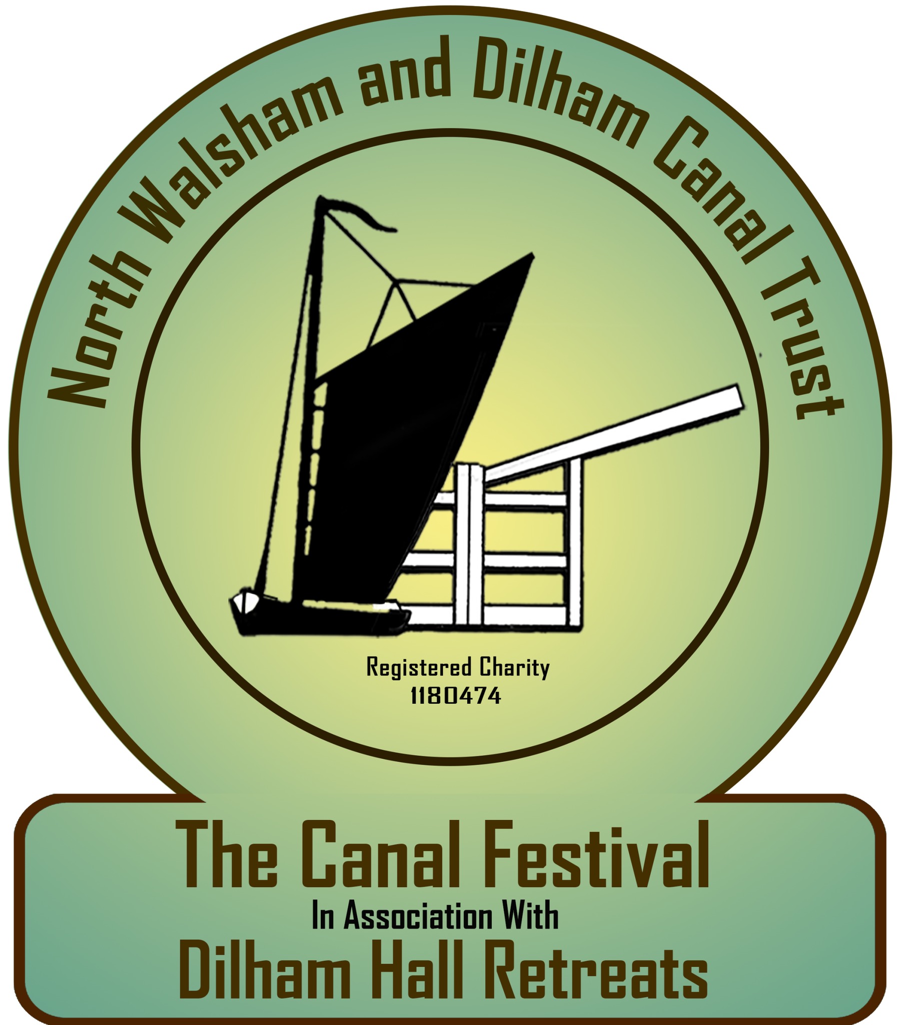

The Canal Festival Entry Form

Please read the Terms and Conditions, then complete and return this form before 1st May 2024.

By completing this form, you are agreeing to the Canal Festival Terms & Conditions

Name:
Company Name:
Items/activity/types of products to display
or for sale
Contact Number:
Email:
Address:

HEALTH & SAFETY. Please confirm that you have and will send copies of the following documents applicable to the festival dates? Please circle or Highlight as appropriate

ESSENTIAL for ALL STALLHOLDERS  Public Liability Insurance (and product insurance and certificates if applicable) | YES | NO
ESSENTIAL for FOOD VENDORS  Fire, Gas and Electrical Certificates and Food Hygiene. | YES | NO
Other documents/certificates: please describe | YES | NO

Do you have any special requests or needs?

Extra space? If so, why and what size?
Power? If so, what and why?
Other?

We do not charge stall holders a pitch fee, however this is a charity run event and if you would kindly make a donation to the North Walsham and Dilham Canal Trust then we would greatly appreciate your support.

Donations can be made to ‘North Walsham and Dilham Canal Trust’:
Sort code: 60-15-54 - Account No: 72562498 - YOUR ref: Name/Postcode

